**Trade Secrets: Warts & Wrinkles**

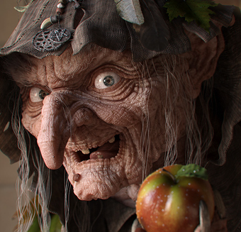

This piece of work entitled “Evil Witch” took three months to complete by Artist Sven Geruschkat. It appeared on the cover and was detailed in issue 107 of 3dworld magazine

<http://www.svenger.de>

This fine detail is a product of diplacement maps from Mudbox and finely detailed (hand painted) bump mapping. The character is inspired by the Witch from Snow White the Swamp Witch from Legend and an old woman reference.

The model was made in 3DS Max 2009, Mudbox 1.0 and CS3 Photoshop. Render times weighing in at 24 hours for a 1,800 x 2,400 pixel image. 64 bit AMD Athalon X2 4200+ processor 2GB ram, ATI Radeon X1800 XT GPU computer.

***Modelling***

The base mesh modelled in 3DS Max was unwrapped and taken into Mudbox and the poly count was kept under 2 million.

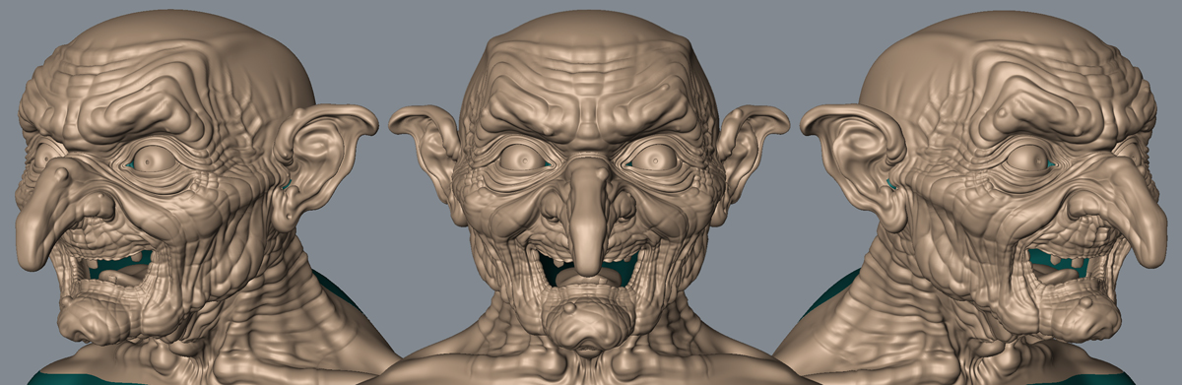

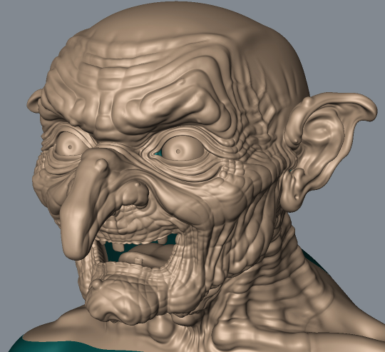

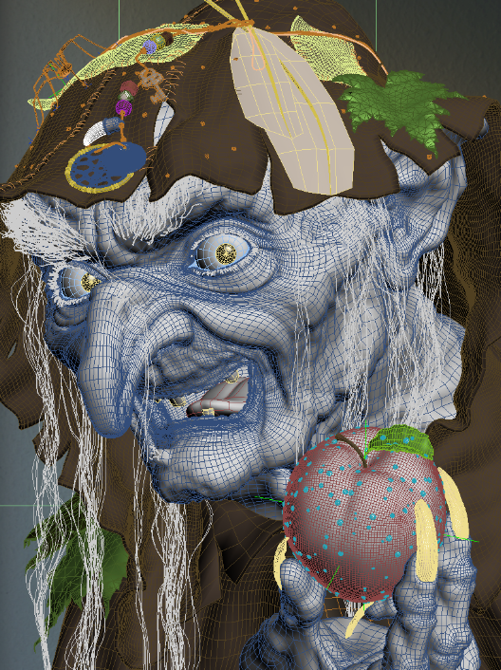

***Textures***

The skin textures were hand painted in Photoshop taking one week overalls. Because the model was symmetrical half a map was produced and simply mirrored across to the other side. They were applied to a SSS Fast skin shader in 3DS Max. Four separate colour maps were required. The bump map was carefully painted up and not a mere grayscale version of the Colour diffuse map. You can see this in detail on another page. Subsurface Scattering shaders were used for the skin, eyes and apple. The scene was lit with a handmade HDRI image and no other lights were used.

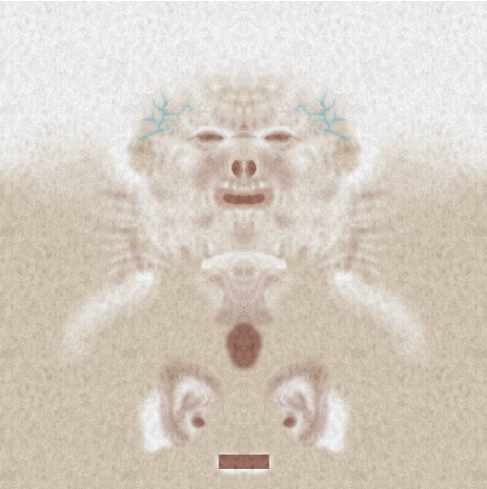 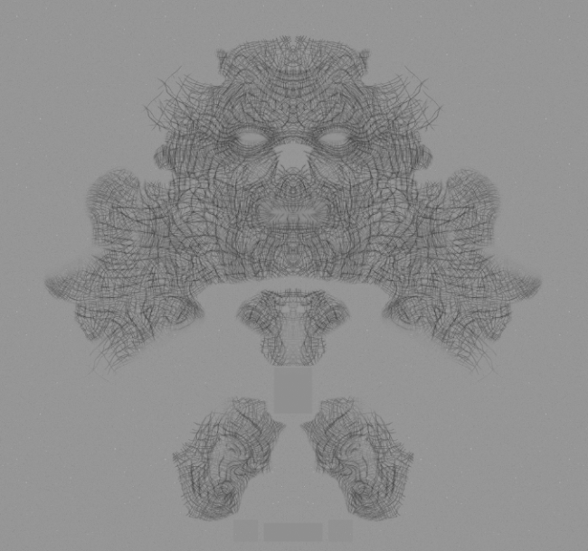

Main Maps:

Diffuse 8 bit 2048 x 4096 300 DPI

Bump 8 bit 2048 x 4096 300 DPI

Displacement Map 16 bit 4096 x 4096 300 DPI

Less Visible Maps:

Reflection Weight 8 bit 512 x 1024 300 DPI

Glossiness 8 bit 512 x 1024

Less Visible Maps:

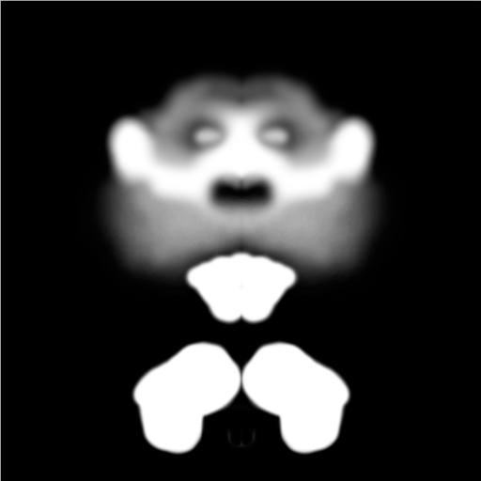 

*Above: 2f_backsurface_weight 2i_subdermal_radius*

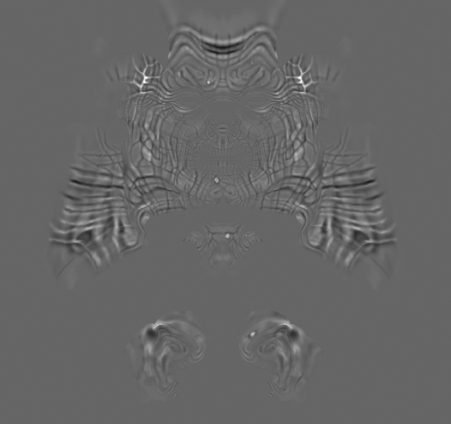 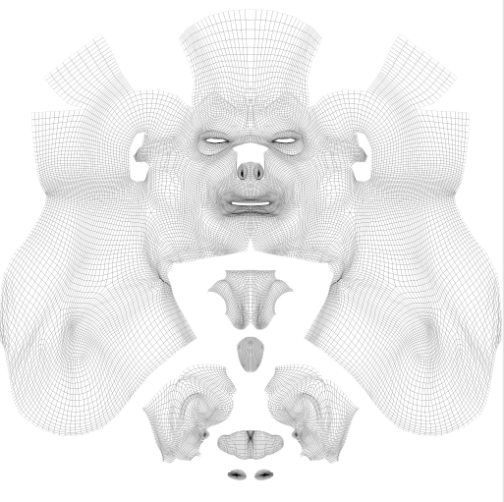

*Above: the 2e_displacement and the UV unwrap*

**

*Above: 2g_reflection glossiness*

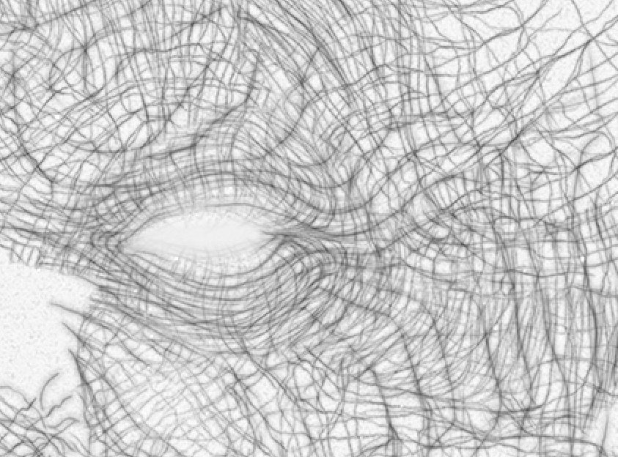

*Here I have deliberately lightened the bump map so you can see the fine line painted detail used for producing the fine wrinkles.*

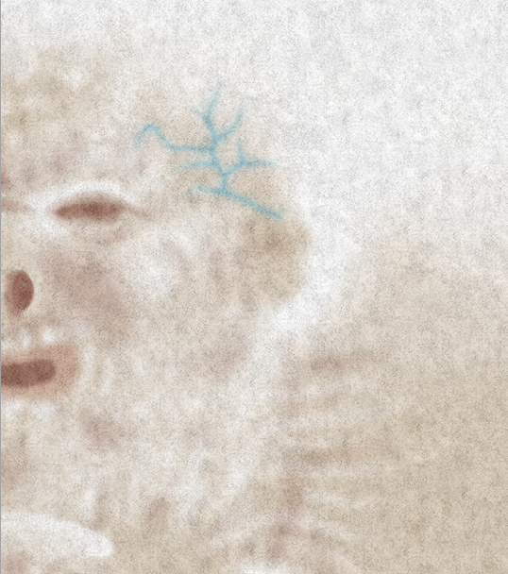

*Close up section of the Colour Map*